Practical 13: PHP JSON API and AJAX/Fetch-Based CRUD without Page Reload
Problem Definition Create simple PHP JSON API endpoints for events or students and
consume them using Fetch API. Perform list, add, update, and delete
operations asynchronously without full page reload.

Theory :

Key Questions / Analysis / Interpretation
1. Do PHP endpoints return valid JSON responses?
Yes. PHP endpoints return valid JSON responses using json_encode() with the appropriate content type header.
2. Are GET and POST requests handled properly?
Yes. GET requests are used to retrieve data, while POST requests are used to submit or process data.
3. Are loading, success, and error states shown on the frontend?
Yes. The frontend displays loading messages while fetching data and shows appropriate success or error messages after processing.
4. Is input validation performed before database operations?
Yes. Input data is validated on the server before performing database operations to ensure correct and safe data processing.
Implementation/out put/result:
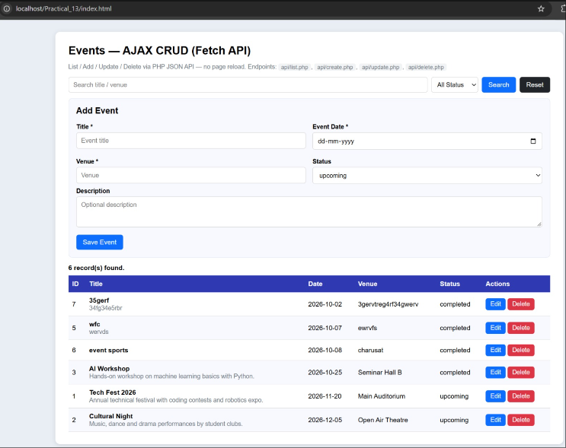

Git hub link:
https://github.com/Ayushsavaliya0305/25dce104-web

Learning outcomes:

Learned to create PHP endpoints that return valid JSON responses.
Learned to handle GET and POST requests properly.
Learned to fetch and send data between the frontend and backend.
Learned to display loading, success, and error messages on the frontend.
Learned to validate user input before performing database operations.
Learned to handle errors and process data using PHP and JavaScript.
Faculty remarks:

